Aristocracy in the 1920’s

### The theme of Aristocracy explored in ‘Jeeves and Wooster’

Aristocracy, the highest class in certain societies typically comprising of people of noble birth holding hereditary titles and offices, is one of the main themes of the Show ‘Jeeves and Wooster’. Jeeves and Wooster is set in 1920’s England and as the title suggests, shows the relationship between a very young rich man ‘Bertie Wooster’ and his valet ‘Jeeves’. The main character Bertie Wooster is best described by his Aunt Agatha as a man who is “Cursed with too much money”, who “wastes his time on frivolous activities”, and is “simply an empty social animal”. In the first episode, Bertie Wooster comes off as immature, rude, irresponsible and condescending while his valet, Jeeves, is an absolute gentlemen who has a strong sense of duty and a clear sense of right and wrong. On one hand where Wooster likens stealing a policeman’s hat to fox hunting and considers it fun, Jeeves is not just good at his job, he excels at it and is always there when his master needs him.

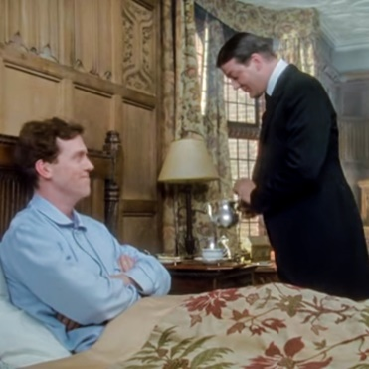Bertie Wooster is an aristocrat who was born supremely rich. He never had to earn his money through hard work; in fact he has never even had a job. He relies on his valet ‘Jeeves’ to do the most menial of works for him; whether it be serving him morning tea which is literally at an arm’s length on his bedside table or lining up the clothes for him to wear during the day. He starts his day by heading straight to the pub to have a few drinks and never does anything productive. He sees nothing wrong with his ludicrously lavish lifestyle and as a result has no regard for anything or anyone apart from himself. This is clearly shown in the scene where he pushes an eight year old boy in the river without having any concern for his safety.

Meanwhile, Jeeves is highly perceptive and always seems to have everything under control. He is a yes man who is fully dedicated to serving his master much like a valet should. He never directly says no to Wooster but at the same time guides and pushes him to make the right choices.From picking the right suit to wear for dinner with a noted nerve specialist or for travelling in a train, to telling him that pushing the kid in the river “is fraught with the possibility of mishap”; Jeeves always has his masters back.

In the Victorian era it was not just the aristocracy who employed servants, new wealth had trickled into cities and led to a burgeoning middle class. Employing a servant was a sign of respectability. A valet was the companion of the master of the house and saw to his every personal need; the valets helped dress and style his master, accompany him, liaise with the other servants, and attend to the private domestic arrangements of his employer, much like Jeeves did for Wooster.

However, the number of domestic servants in England has dwindled in the 20th Century, particularly for the middle classes, and World War I and II had a profound effect. With the men sent to fight, women dominated the traditional male working roles in munitions factories, making uniforms etc. After the war, many women and men did not return to their domestic service roles. The 21st Century domestic workers in England now tend to be self-employed entrepreneurs, running their own ironing businesses from home or their own cleaning service franchise. It is fair to say that the master/servant relationship had become less defined.

**Bibliography:**

* “The Servant Hierarchy.” *Countryhousereader*, 27 Jan. 2014, countryhousereader.wordpress.com/2013/12/19/the-servant-hierarchy/.
* “Culture & Sexuality in the Jazz Age.” *Western Civilization*, lisahistory.net/hist104/pw/lectures/20s30s/3fashion.htm.
* Wallis, Lucy. “Servants: A Life below Stairs.” *BBC News*, 22 Sept. 2012.
* Guide, British Comedy. “Jeeves And Wooster Characters.” *British Comedy Guide*, www.comedy.co.uk/tv/jeeves_and_wooster/characters/.
* Gautam Malhotra – 1740255

**Clear Understanding of the text**

* Jeevan Koshi – 1740256

**Coherence**

* Madhav Shroff – 1740213

**Grammatical Correctness**

* Mayuri Salecha – 1740229

**Inventiveness in the use of language**

* Yash Raj – 1740247

**Contemporary relevance**